Create a Load Balanced VM Scale Set in Azure
SOP



Table of Contents

1. Create a Load Balanced VM Scale Set in Azure 3
1.1 Description 3
1.2 Architecture Diagram 3
1.3 Lab Steps 4
1.4 Troubleshooting 6
1.5 Supporting References 6

1. Create a Load Balanced VM Scale Set in Azure

1.1 Description
Virtual machine scale sets provide redundancy and improved performance, applications are typically distributed across multiple instances. Customers may access your application through a load balancer that distributes requests to one of the application instances. If you need to perform maintenance or update an application instance, your customers must be distributed to another available application instance. To keep up with additional customer demand, you may need to increase the number of application instances that run your application.
Azure virtual machine scale sets provide the management capabilities for applications that run across many VMs, automatic scaling of resources, and load balancing of traffic.

1.2 Architecture Diagram
The diagram below displays a visual representation of the application architecture:
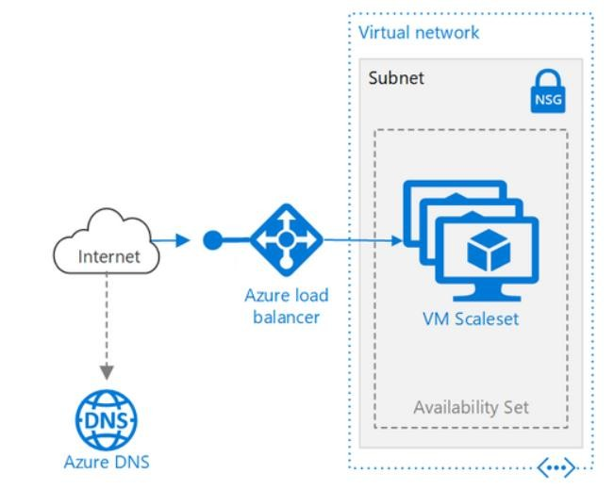

1.3 Lab Steps
Follow the steps outlined below to achieve the objective of this lab exercise:

- Create a Load Balancer:
  - Go to azure portal, search for load balancer and click create.
  - Provide the following details, please note that the values given here are sample ones:
    - Resource Group: Your Resource Group name
    - Name: labloadbalancer
    - Region: Central US
    - Type: Public
    - SKU: Standard
    - Public IP Address: Create New
    - Public IP address name: labpublicip
    - Availability Zone: Zone-redundant
  - Leave other fields with their default values and click Create.
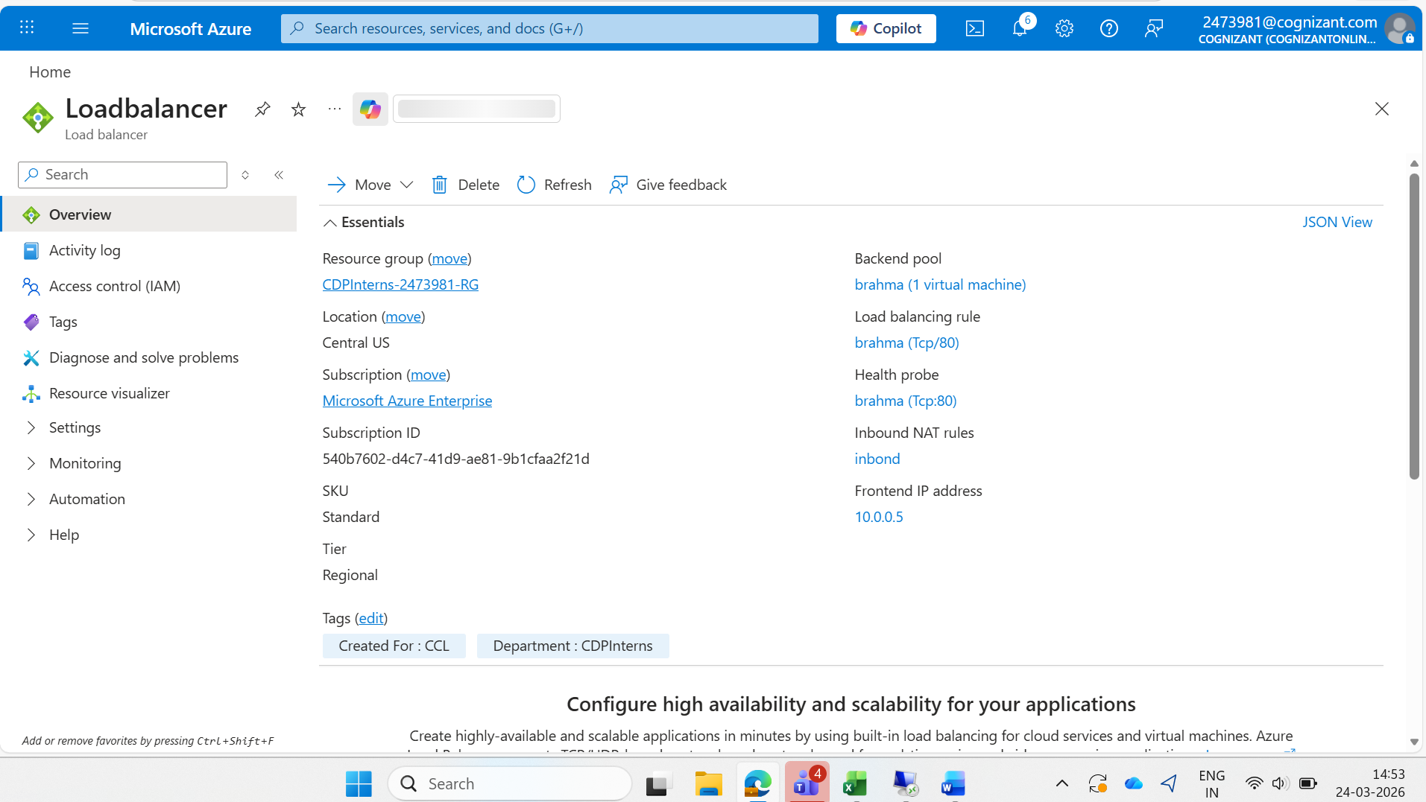

- Create virtual machine scale set:
  - Type Scale set in the search box, select Virtual machine scale sets and click Create.
    - Resource Group: Your Resource Group Name
    - Scale Set Name: labvmss
    - Availability Zone:1
    - Image: Windows Server 2019 Datacenter
    - Size: Standard_B2ms
  - Provide username and password
  - Go to Networking Blade.
  - Virtual Network: Create new Virtual network
    - Name: labvnet
    - Resource Group: your Resource Group
    - Replace the name of default subnet with the name labsubnet
    - Click OK
  - Network Interface: Create new Nic
    - Name: labnic
    - Subnet will be selected as labsubnet
    - NIC network security group: Advanced
    - Network Security Group: create new and give it a name lbnsg
    - Public IP address: Enabled
    - Click Create
    - Now select the default nic (labvnet-nic01) and click Delete
  - Load Balancing: No
  - Go to Management Blade and select Boot Diagnostics: Off
  - Leave rest of the fields with their default values and click Create.
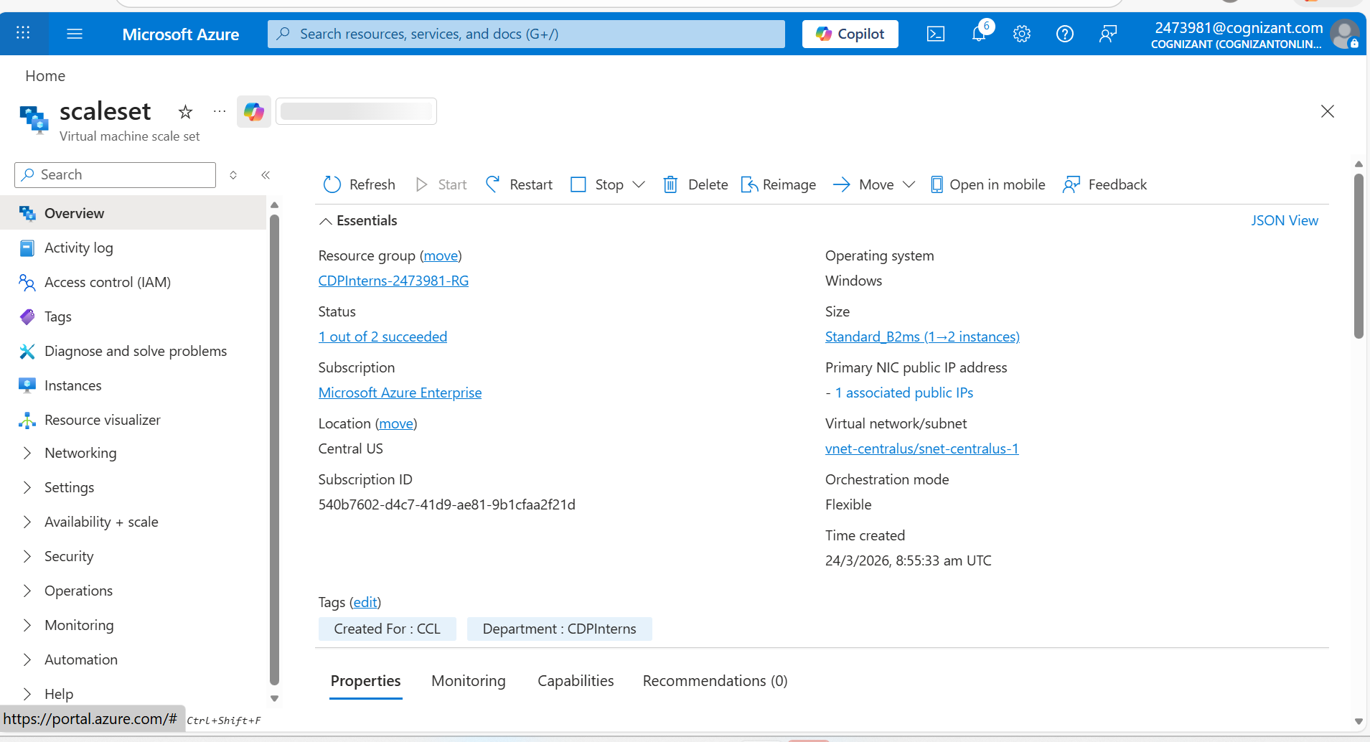

- Configure the Network Security Group for port 80:
  - Go to the lbnsg Network Security Group.
  - Go to Inbound Security Rules
  - Click Add
  - Source: Service Tag
  - Source Service Tag: Internet
  - Source Port Ranges: *
  - Destination: Any
  - Destination Port Ranges: 80
  - Protocol: TCP
  - Action: Allow
  - Priority: 100
  - Name: Port_80
  - Click Add.

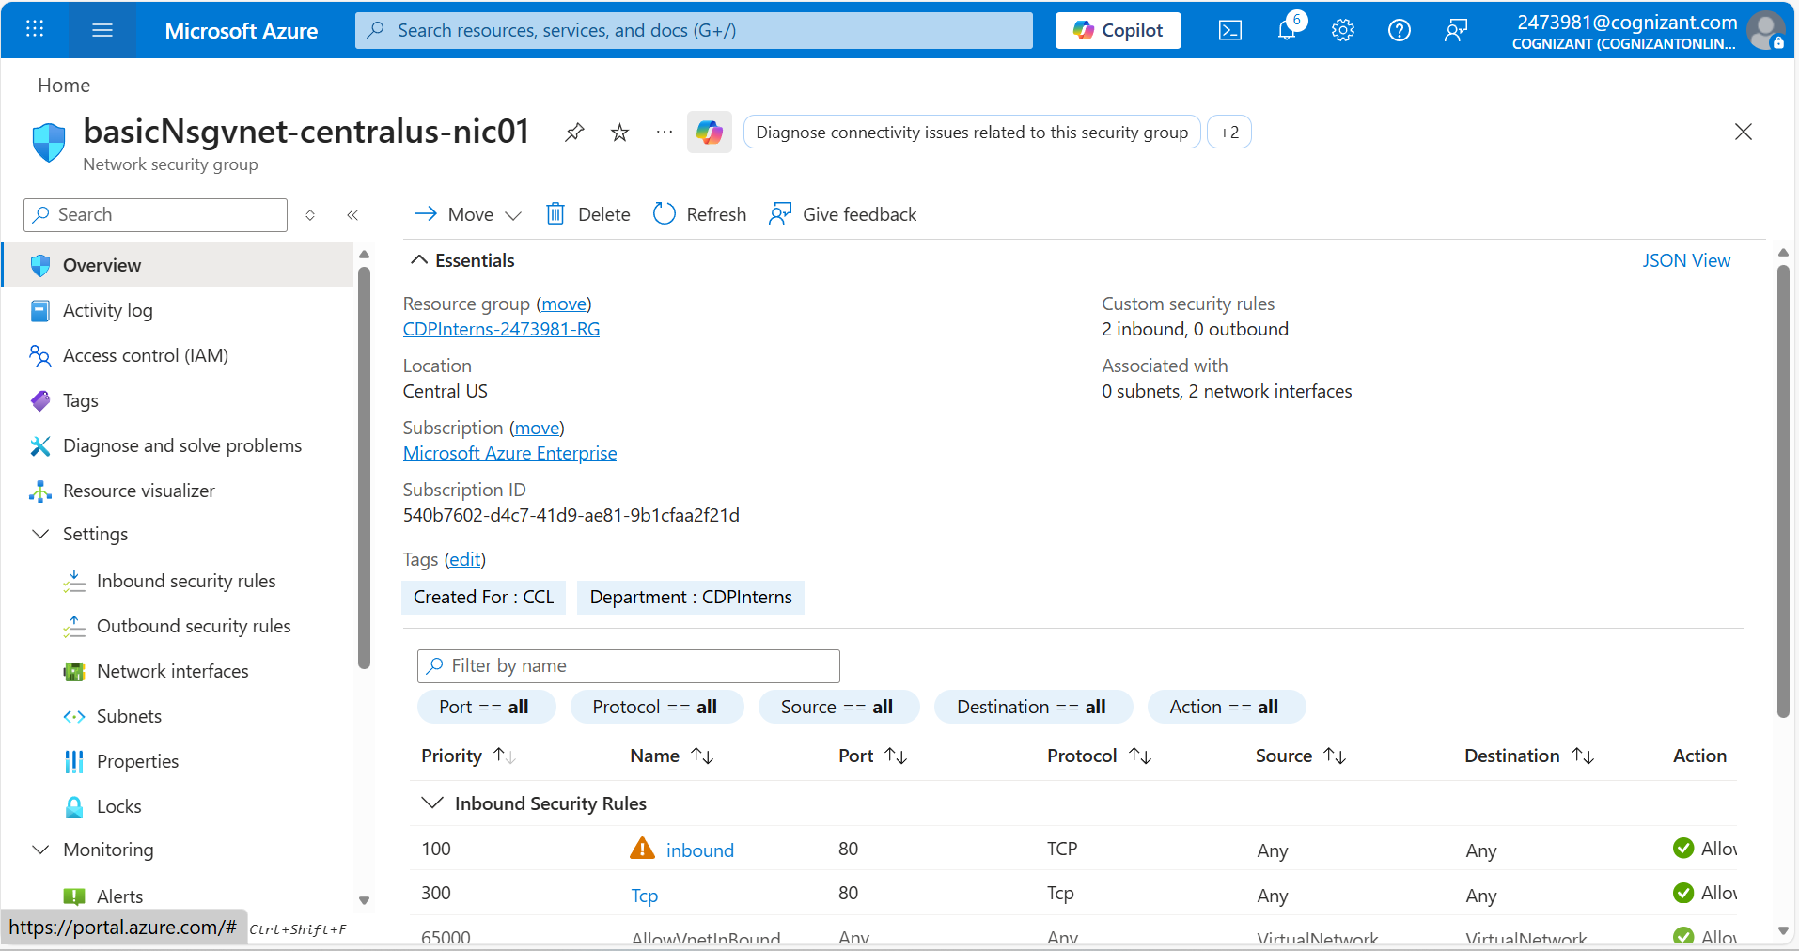

- Configure Load Balancing on VMSS:
  - Go to the labloadbalancer you created earlier.
  - Go to the Backend Pools and click Add:
    - Name: labbackendpool
    - Virtual Network: labvnet
    - Associated to: Virtual Machine Scale set
    - From VMSS drop down, select labvmss
    - From IP address, select the default IP of labvmss
    - Click Add.
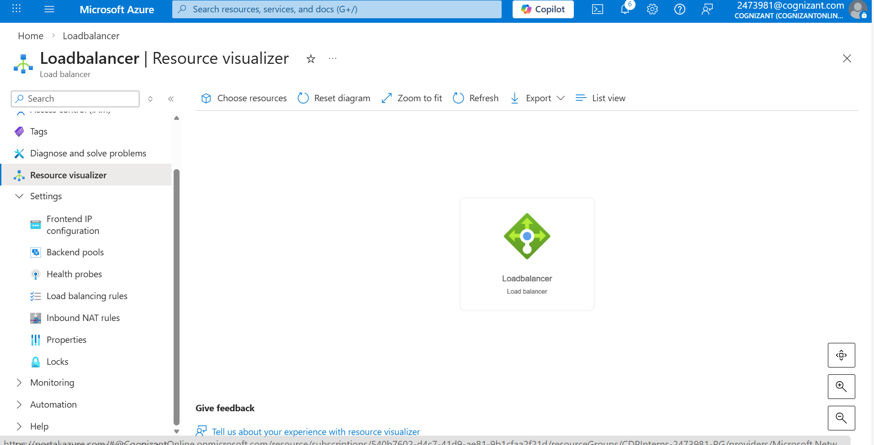
  - Go back to the load balancer and click Health Probe > Add:
    - Name: labhealthprobe
    - Protocol: HTTP
    - Port: 80
    - Leave other fields with their default values and click OK.
  - Go to the load Balancing Rules, click Add:
    - Name: labloadbalancerule
    - Frontend IP Address: selected by default
    - Protocol: TCP
    - Port: 80
    - Backend Port: 80
    - Backendpool: labbackendpool
    - HealthProbe: labhealthprobe viii. Leave other fields with their default values and click OK.

- Create another virtual machine in the same virtual network:
  - Go to the portal and create a virtual machine.
    - VM Name: labvm
    - Region: Central US(same as vmss and Vnet)
    - Image: Windows server 2019 Datacenter
    - Size: Standard_B2ms

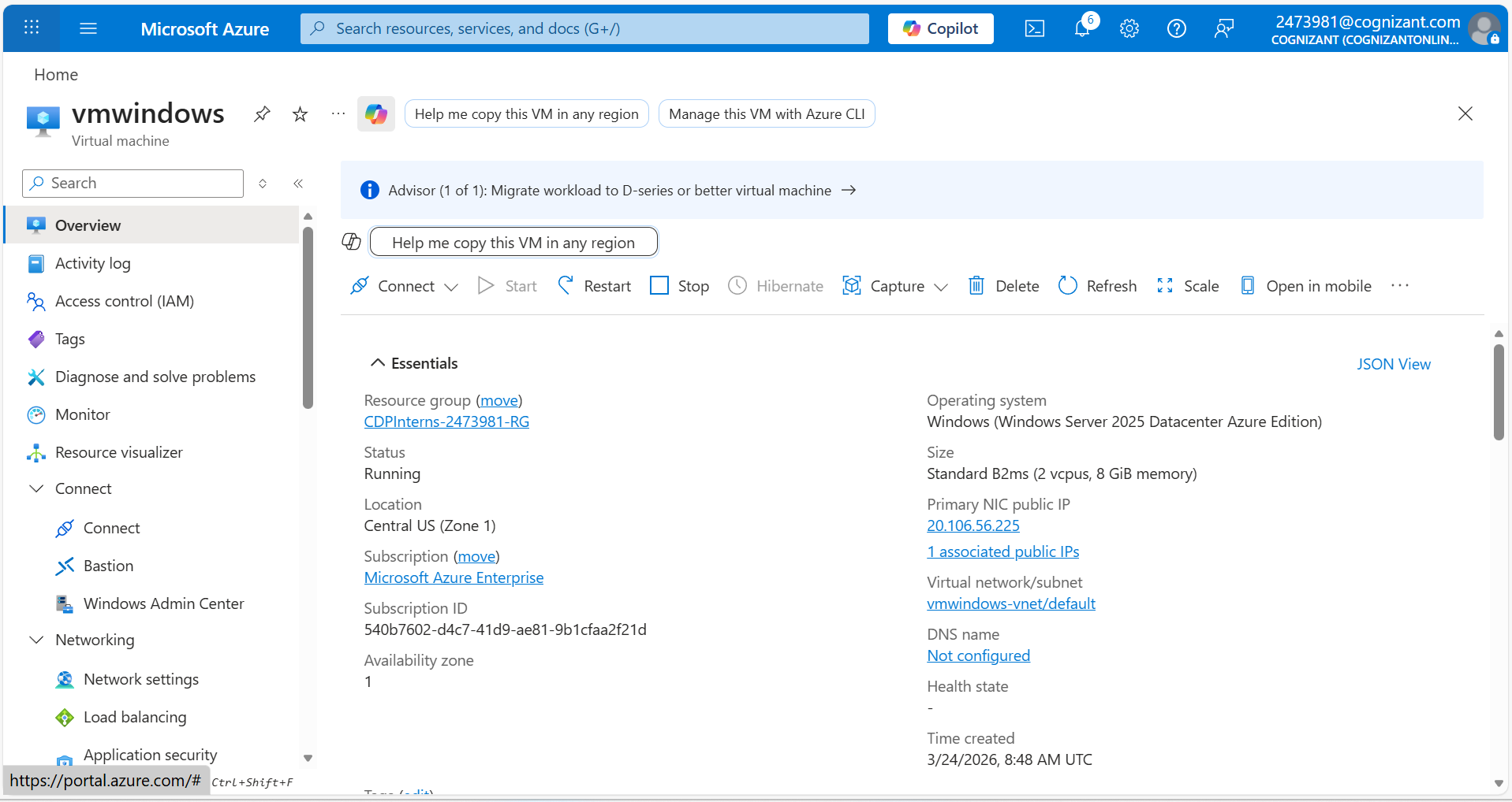
  - Go to networking blade.
    - Virtual Network: labvnet (should be same as VMSS)
    - NIC network Security Group: Advanced
    - Configure network security group: lbnsg (same as VMSS)
    - Load Balancing: No
    - In Monitoring, set Boot Diagnostic: off
  - Click Create.

- Install IIS:
You have to install webserver in each instance of VMSS, and you will be using labvm to connect both instances of VMSS.
  - Connect to the labvm by RDP file with the credentials provided during creation.
  - Go to the Virtual Machine scale set, go to instances, note down the private IP of both the instances.
  - From labvm Virtual machine, RDP to vmss instance 1.
  - Type Windows +R, in Run prompt, type mstsc.
  - In the Connect window, provide the Private IP address of first instance and then provide credentials. You are now logged in instance 1.
  - Open windows Powershell in instance 1 VM and type the following commands to install IIS webserver:
# install IIS server role
Install-WindowsFeature -name Web-Server -IncludeManagementTools
# remove default htm file remove-item C:\inetpub\wwwroot\iisstart.htm # Add a new htm file that displays server name
Add-Content -Path "C:\inetpub\wwwroot\iisstart.htm" -Value $("Hello World from " + $env:computername)
  - Repeat the same set of steps for the other instances of Virtual machine scale set.

- Test the Load Balancer:
  - From the load balancer, note down the Public IP of load balancer.
  - Hit the Public IP in your browser, you will find the response coming from one of the instances of
VMSS.
  - Try the force Refresh by pressing ctrl+F5, you will find the response coming from the other instances of VMSS.

- Delete the Resources:
  - When no longer needed, delete the resource group, scale set, and all related resources.
  - To do so, select the resource group for the scale set and then select Delete.

1.4 Troubleshooting
S. No | Problem | Solution
1 | Not able to connect to VM | Check if RDP port 3389 is enabled, if not, add inbound rule to allow traffic to port 3389
2 | Load Balancer URL not working | - Ensure to upgrade all instances of VMSS after connecting it to a load balancer  - Check if webserver is installed on VMSS Instances
3 | VM are in unhealthy state | Lower size VMs are generally not supported in Load Balancing, try changing the size of VM

1.5 Supporting References
Refer the below link for additional information:

1. https://docs.microsoft.com/en-us/azure/load-balancer/quickstart-load-balancer-standard-public-portal

